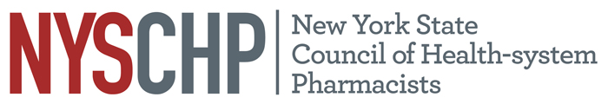
230 Washington Ave Extension, Albany NY 12203 - 518-456-8819

2017 HOUSE OF DELEGATES

Bolton Landing, NY

April 27, 2017

REPORT OF THE EXECUTIVE DIRECTOR

Shaun C. Flynn

This report is for consideration by the New York State Council of Health-system Pharmacists House of Delegates only and does not represent official policy until approved the House of Delegates.
- Responsibilities of the Executive Director

The Executive Director shall be responsible for the administrative activities of NYSCHP including direction of all operations, programs and activities. The Executive Director shall at all times, support the vision, mission and goals of NYSCHP.

- Operations

  - Administration
      - The 2018 Annual Assembly will be held on April 26 – April 30, at the Saratoga Hilton, Saratoga Springs, NY.
      - Tri-State Educational Program is tentatively scheduled for September 29, 2017 in Tarrytown NY.
      - NYSCHP continues to provide administrative support for the New York State Council of Health-system Pharmacists Research and Education Foundation (REF) and assists in the administration of the REF awards.
      - NYSCHP provided successful practice based (certificate) continuing professional education programs in Antimicrobial Stewardship in conjunction with the Greater New York Hospital Association and the Pennsylvania Hospital Association.
      - The Council migrated the administrative services for the organization over to Capitol Hill Management Services to reduce costs and provide additional accounting and meeting planning support that had been identified as a need by the Board of Directors.
      - A new membership database was implemented during the fall of 2016. Approximately 15,000 database records were reviewed and cleaned up. The new system includes improved billing and integration with the Council’s accounting system.
      - A complete overhaul of the Council website was conducted as part of the new database project. The new site features a cleaner and more modern appearance as well as improvements in functionality.The implementation of the web site included the review of over 10,000 old documents and pages in the back end of the old site. This clean-up will reduce the amount of technical errors for the site moving forward.
      - The Council office has addressed all of the management issues identified in the 2016 audit. Most of these improvements were the result of the transition to Capitol Hill Management Services which provides complete separation of duties, financial statements that follow GAAP guidelines, and access to a CPA.
      - A new on-line educations service was implemented to allow the Council to start conducting webinars. The program was tested and is now being utilized for regular on line education. It was also utilized to conduct the first Virtual House of Delegates.

      - Cost containment efforts have been very successful in improving the health of the Council’s finances. The move to Capitol Hill management Services is projected to save to Council between $30,000-$40,000 per year, with most of those savings being from reduced overhead costs. The new package of services they provide also enabled the Council to avoid an additional $35,000 to $50,000 in new costs for implementing enhanced accounting practices, additional meeting planning services and projected increases in costs for contracted services ending in late 2016/early 2017. We continue to explore ways to contain costs and streamline operations.
      - Social media activity for the Council has been increased to make them better resources for information. As a result of these efforts we have increased our followers on all accounts.

- Activities

Nationally: I have represented NYSCHP at the following ASHP events: and the 2016 Midyear Clinical Meeting in Las Vegas, Nevada, the 2016 ASHP Lobby Day in Washington DC and the 2016 PTCB Affiliates meeting in Alexandria Virginia.

State: On the state level, I have attended meetings with the Alliance of New York Licensed Health Professionals (ANYLHP), IPRO, Empire state Society of Association Executives (ESSAE), NYS Cancer Consortium Steering Committee, NYS Pharmacy Conference, NYS Senate, NYS Assembly, NYS Office of the Professions, the State Education Department, State Department of Health, Bureau of Narcotic Enforcement and NYS Board of Pharmacy. NYSCHP continues to work collaboratively with PSSNY, the Chain Pharmacy Association and ASCP to promote our mutual legislative agendas. I also serve as the chair of the NYS Pharmacy Conference during 2017. I will continue to work to expand the Council’s visibility in these areas and pursue avenues for NYSCHP to provide input with regard to professional and legislative issues that promote and enhance the pharmacy profession.

Respectfully submitted,

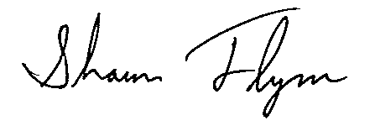
Shaun C. Flynn
Executive Director

